

American International University-Bangladesh (AIUB)  
Department of Computer Science  
Faculty of Science &Technology (FST)  
Spring 22 23

Section: K  
Software Quality Assurance and Testing

**Hospital Management System**

A Report submitted

By

|  |  |  |
| --- | --- | --- |
| SN | Student Name | Student ID |
| 1 | SADMAN SAKIB | 20-43159-1 |
| 2 | MD FARHAN UL ASIF | 20-43522-1 |
| 3 | ARPON KARMAKAR | 20-43493-1 |

Under the supervision of

**MOHAMMAD ARIFUR RAHMAN**

ASSISTANT PROFESSOR,CS

Software Test Plan

for

<Hospital Management System>

Version 1.0 approved

Prepared by < SADMAN SAKIB (20-43159-1) , MD FARHAN UL ASIF(20-43522-1) , ARPON KARMAKAR(20-43493-1)>

< AMERICAN INTERNATIONAL UNIVERSITY- BANGLADESH>

<03.05.2023>

**Checked By Industry Personnel**

Name:

Designation:

Company:

Sign:

Date:

Table of Contents

Revision History 4

1. TEST PLAN IDENTIFIER:HMS-V1.0 4

2. REFERENCES 4

3. INTRODUCTION 4

Background to the Problem 4

Solution to the Problem 4

4. REQUEIREMNT SPECIFICATION 5

4.1 System Features 5

3.2 User must fill all the required info. 6

5. Blood management 6

4.2 System Quality Attributes 9

4.3 System Interface 10

4.4 Project Requirements 13

5. FEATURES NOT TO BE TESTED 13

6. TESTING APPROACH 13

6.1 Testing Levels 13

6.2 Test Tools 14

6.3 Meetings 14

7. TEST CASES/TEST ITEMS 15

8. ITEM PASS/FAIL CRITERIA 23

9. TEST DELIVERABLES 23

10. STAFFING AND TRAINING NEEDS 23

11. RESPONSIBILITIES 24

12. TESTING SCHEDULE 25

13. PLANNING RISKS AND CONTINGENCIES 26

14. APROVALS 26

# Revision History

|  |  |  |  |
| --- | --- | --- | --- |
| Revision | Date | Updated by | Update Comments |
| 0.1 | 2023.04.01 | SADMAN SAKIB | First Draft |
| 0.2 | 2007.04. 02 | ARPON KARMAKAR | Second Draft |
| 0.3 | 2023.04.23 | MD FARHAN UL ASIF | Third Draft |

# TEST PLAN IDENTIFIER:HMS-V1.0

# REFERENCES

SRS DOCUMENT LINK:

https://drive.google.com/drive/folders/17tbUwKSRKDm88sKQhS8a9lWFdc7Itlnd?usp=share_link

# INTRODUCTION

## Background to the Problem

The management of patient data and the delivery of quick and efficient healthcare services provide various issues for the healthcare sector. Healthcare providers are looking to technological solutions like healthcare management systems to simplify procedures and enhance patient outcomes as the sector continues to change and adapt to shifting patient requirements. A healthcare management system is an application of software that helps in the administration of patient information, appointments, medical records, billing, and other operational duties. These systems allow healthcare professionals to follow patients' progress, get patient data properly, and automate several time-consuming administrative activities, all of which contribute to better patient care. A healthcare management system's objective is to improve the standard of patient care while reducing costs and increasing provider productivity.

## Solution to the Problem

A web application called a healthcare management system (HMS) is made to improve patients' and providers' access to healthcare easier and better. With the help of the system, people may register online, make appointments, and get expert medical advice. Patients may easily manage their health and well-being from the convenience of their own homes thanks to an accessible interface and automatic functions.

To ensure quick and dependable performance, the Healthcare Management System was developed using the most recent technology and programming languages. To provide customers a smooth experience, the system uses PHP, JavaScript with a clear and expressive syntax. The user interface is made to be accessible from any platform, including desktop, laptop, tablet, and smartphone, thanks to its modern, responsive design.

Patients may quickly and easily create an online profile with their personal data, medical history, and insurance information. The system securely stores this data, and it is updatable as necessary. Patients may use the system to schedule appointments with their preferred physicians, nurses, and specialists. Patients get access to a calendar of their coming appointments, reminders, and the ability to change or cancel them as necessary.

Healthcare professionals can also use the Healthcare Management System's patient management, medical record keeping, and appointment scheduling functions. Through the system, providers can communicate with patients, update medical records, and access patient data. The system also has a feedback component that enables patients to share their opinions on their interactions with healthcare professionals.

# REQUEIREMNT SPECIFICATION

## System Features

**1.****Registration:**

1.1  When users will fill up the registration form they should give only valid information.

1.2 They have to give their correct email address, phone number, Date of birth .

1.3 Their information will be verified later.

**Priority Level:** High  
 **Precondition:** This registration is only for patients.

**2. Login**

1.1 User login into the system with a username and password according to registration.

1.2  The login information will be cross-checked against database records.

1.3 If the login is successful, the user account's home page is displayed.

1.4  if the username or password are entered incorrectly then the system will produce a error message .

**Priority Level:** High  
 **Precondition:** The user has a valid username and password

**3.Profile Update & View:**

3.1 All user can modify their profile.

## 3.2 User must fill all the required info.

**Priority Level:** Medium   
 **Precondition:** user has to be valid.

**4. Appointment management**

4.1. Only for valid admin.

4.2. An admin can modify any appointment.

**Priority Level:** Medium   
 **Precondition:** user has to be a valid admin.

## 5. Blood management

5.1. Only for valid admin.

5.2. An admin can view the blood bank list and also modify them

**Priority Level:** Medium   
 **Precondition:** user has to be a valid admin.

**6. View and Search the Doctor's Daily Schedule**

6.1. Any patient (users)  can view this page.

6.2. Doctors' daily schedules were previously stored in the database.

**Priority Level:** Low  
 **Precondition:** user must log in to see the doctor's schedule.

**7. View the Services List**

7.1. Any patient (users)  can view this page.

7.2. All the services provided by the hospitals were previously stored in the database.

**Priority Level:** Low  
 **Precondition:** user must log in to see the services list.

**8. View Patient Medical History & Add Prescriptions**

8.1. Allow doctors to view a patient's medical history and add prescriptions.

8.2. Doctors can Provide a comprehensive list of past medical treatments, diagnoses, and prescriptions.

**Priority Level:** High  
 **Precondition:** user must be a valid doctor

**9. Operation & Appointment Schedules Management**

9.1. Allow authorized staff **(Doctors)** to manage the operation and appointment schedules.

9.2. Provide appropriate error messages if the staff is not authorized to manage the

**Priority Level:** High

**Precondition:** user must be a valid doctor

**10. User Management**

10.1. Allow authorized staff(Admin) to create, view, update and delete user accounts.

10.2. Ensure that users have appropriate access rights based on their roles.

10.3. Provide appropriate error messages if the user enters invalid information.

**Priority Level:** High  
**Precondition:** user must be a valid Admin.

## System Quality Attributes

## Security: The system should be designed to protect the confidentiality, integrity,    and availability of patient and healthcare data, and comply with relevant regulations and standards.

## Priority Level: High Precondition: N/A

## Usability: The system should be easy to learn and use, with a consistent and intuitive user interface, and provide appropriate feedback to users.

## Priority Level: Medium Precondition: N/A

## Reliability: The system should be reliable and operate without significant downtime or data loss, and provide mechanisms for fault tolerance, error recovery, and data backup.

## Priority Level: High Precondition: N/A

## Scalability: The system should be able to scale up or down to accommodate changes in user demand, data volume, and system complexity.

## Priority Level: High Precondition: N/A

## Performance: The system should be able to handle a large number of concurrent users, transactions, and data without significant degradation in response time or system availability.

## Priority Level: Medium Precondition: N/A

## Interoperability: The system should be able to exchange data and communicate with other healthcare systems, such as electronic health record systems, medical devices, and other healthcare applications.

## Priority Level: Medium Precondition: N/A

## Performance Monitoring: The system should provide mechanisms for monitoring system performance and detecting and responding to performance issues.

**Priority Level:** High  **Precondition:** N/A

## System Interface

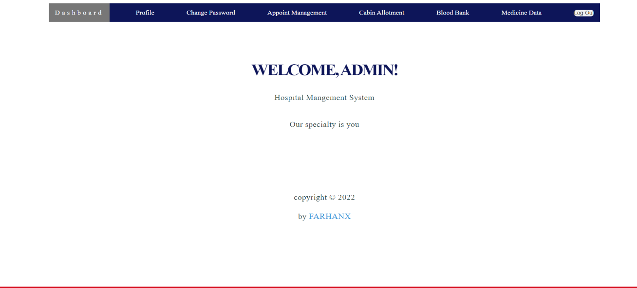

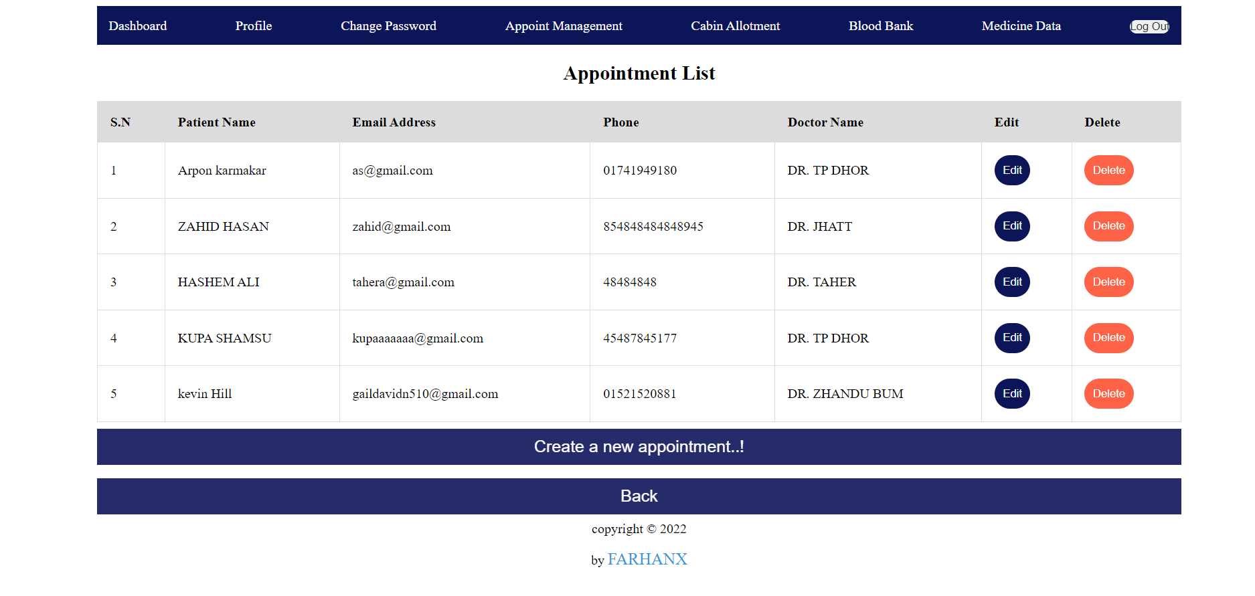



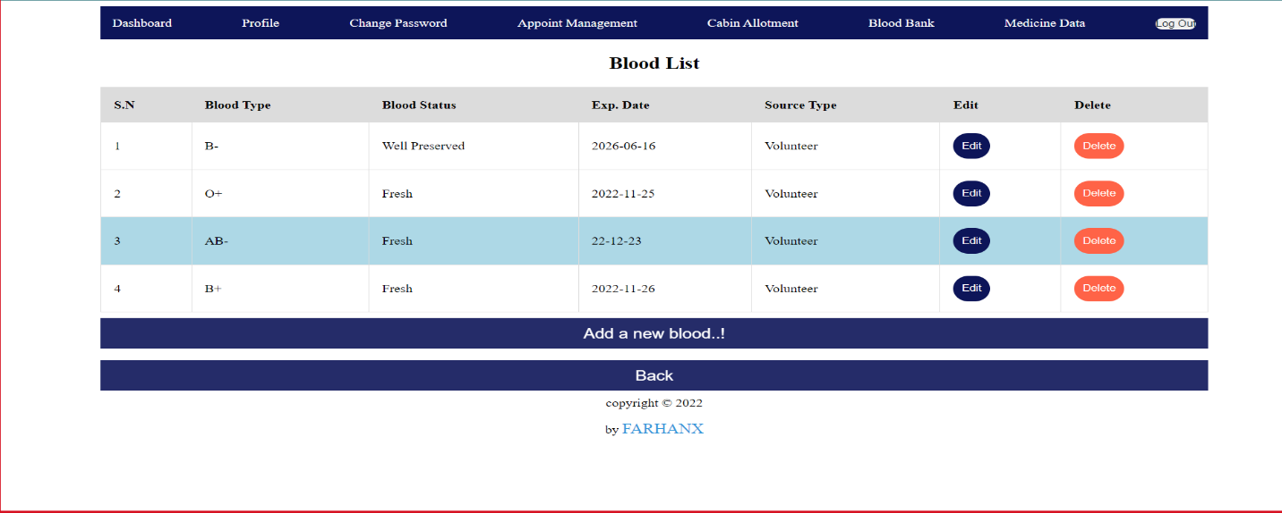



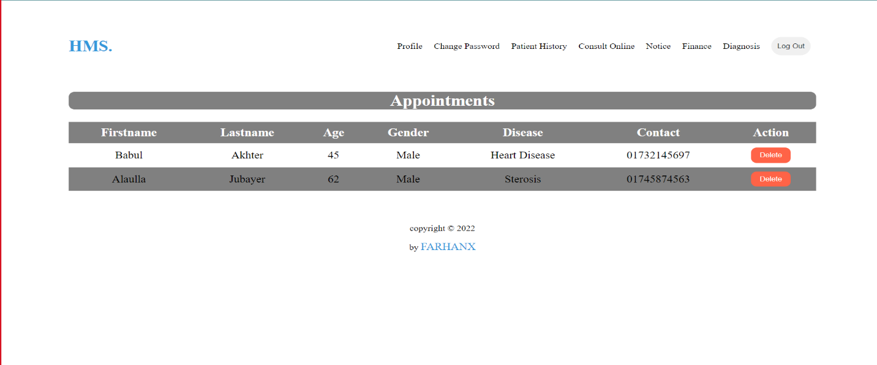

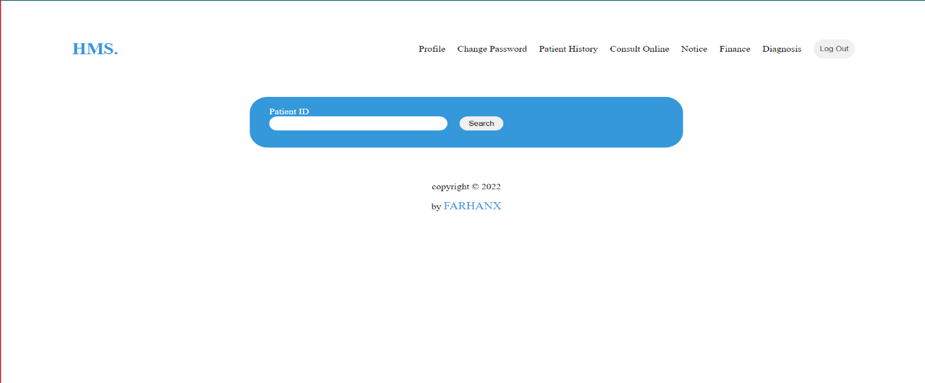

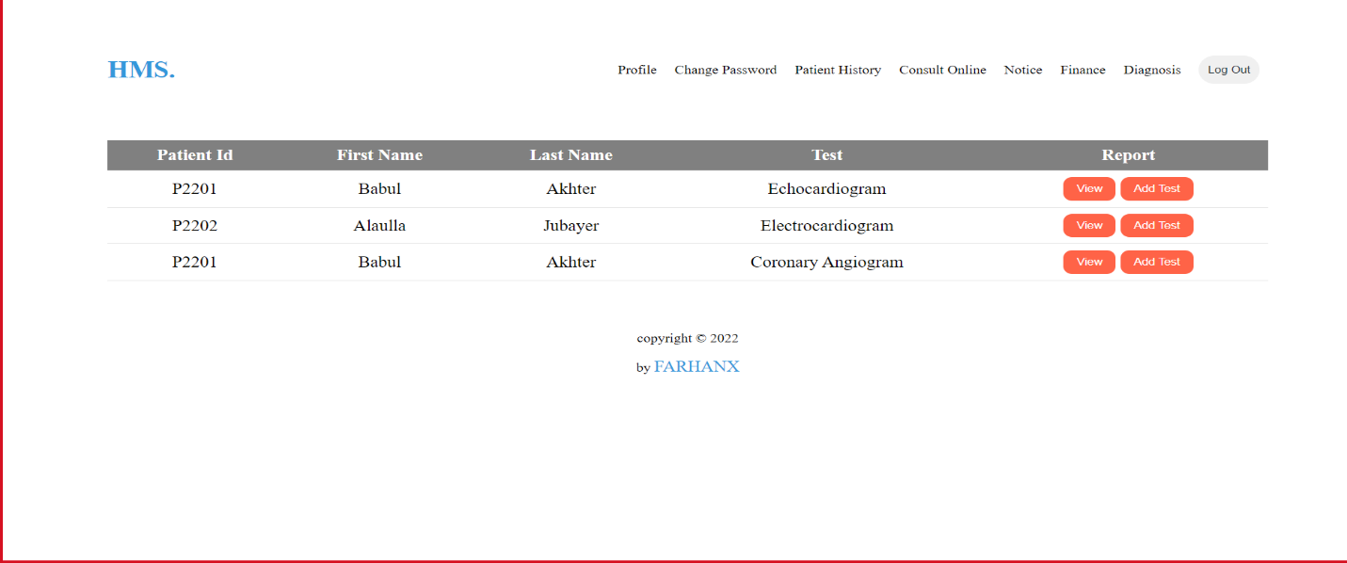

## Project Requirements

List of some project requirement for Hospital Management System .these are:

Budget: The Hospital Management System development, testing, and deployment expenditures are all included in the project's overall budget of $5000.

Time: The project's delivery date of June 30, 2024, is expected to be within a 12-month period.

Resources: A project manager, software developers, testers, and UX designers will be among the development team's ten members.

Environment: The healthcare's existing IT infrastructure should be compatible with the programming languages and the latest technologies used to construct the hospital management system.

# FEATURES NOT TO BE TESTED

The following is a list of the areas that will not be specifically addressed. All testing in these areas will be indirect as a result of other testing efforts. For example:

In this project some Feature not to be tested:

1. Profile Update

2. Change Password

3. User Internet Connectivity

4. User Transection Gate way

# TESTING APPROACH

## Testing Levels

In this project, we'll put a test plan to improve the healthcare system to behavior. We must go through three main stages of testing to make sure the software is of a good quality. Functional testing, integration testing, and acceptance testing are some of these phases.

Functional Testing: To make sure the system satisfies all functional criteria, we'll use black-box and white-box testing strategies. White-box testing will focus on evaluating the internal workings of the system, while black-box testing will focus on testing the system as seen by the user.

Unit testing: To make sure the system's modules are operating as intended, we will do unit testing on each module individually. After finishing each module, we will execute the test cases we have created for each unit. To make sure that any flaws are found and corrected early in the testing process, we will employ both static and dynamic unit testing methodologies.

Integration Testing: To make sure that all individual modules function properly when integrated into the system, we will conduct system integration testing. To guarantee that all interactions between modules are accurate, we will develop test cases for the interface between system components.

Acceptance Testing: The final stage of testing is acceptance testing. This will be done by the final users with the help of our development team. The goal of acceptance testing is to ensure that the system meets all the user requirements. During this phase, we will create test cases that focus on the system's usability, reliability, and performance. We will also ensure that the system meets all regulatory requirements.

## Test Tools

A "Hospital Management System" software application may be tested using any number of test tools available on the market. For in this project have used Selenium.

Selenium: This is an automated testing tool that is available for free and is frequently used to test web applications.

## Meetings

In a software testing meeting, testers for a particular software application get together to talk about how the testing is going, any problems they've found, and any necessary next steps. This can include poring over the test findings, locating any errors or faults in the program, and figuring out how to fix them. Before to being made available to the general public, the meeting's objective is to make sure the software is in good working order and complies with all applicable requirements. The project manager, senior test engineer (test lead), junior test engineer, testing manager, database analyst, and others could attend the software testing meeting.

# TEST CASES/TEST ITEMS

|  |  |  |  |  |  |
| --- | --- | --- | --- | --- | --- |
| Project Name: Hospital Management System | | | Test Designed by: MD FARHAN UL ASIF | | |
| Test Case ID: FR_1 | | | Test Designed date: 03.04.2023 | | |
| Test Priority (Low, Medium, High): Medium | | | Test Executed by:SADMAN SAKIB | | |
| Module Name: Appointment List | | | Test Execution date:03.04.2023 | | |
| Test Title: User can read, create ,update and delete . | | |  | | |
| Description: Test website Appointment List | | |  | | |
| Precondition (If any): User must have valid username and password and role must be admin. | | | | | |
| Test Steps | Test Data | Expected Results | | Actual Results | Status (Pass/Fail) |
| 1. Go to the website 2. Enter username 3. Enter password 4. Click login 5. Go to Appointment management | Username: fxFarhan  Password: 123 | User should view, create, update and delete | | As expected, | Pass |
| Post Condition: Updated data should post to the database and also the appointment list page should fetch the data from the data base. | | | | | |

|  |  |  |  |  |  |
| --- | --- | --- | --- | --- | --- |
| Project Name: Hospital Management System | | | Test Designed by: MD FARHAN UL ASIF | | |
| Test Case ID: FR_2 | | | Test Designed date: 03.04.2023 | | |
| Test Priority (Low, Medium, High): Medium | | | Test Executed by:SADMAN SAKIB | | |
| Module Name: Blood Bank | | | Test Execution date:03.04.2023 | | |
| Test Title: User can read, create ,update and delete . | | |  | | |
| Description: Test website Blood Bank | | |  | | |
| Precondition (If any): User must have valid username and password and role must be admin. | | | | | |
| Test Steps | Test Data | Expected Results | | Actual Results | Status (Pass/Fail) |
| 1. Go to the website 2. Enter username 3. Enter password 4. Click login 5. Go to Blood Bank | Blood Group : | User should view, create, update and delete | | As expected, | Pass |
| Post Condition: Updated data should post to the database and also the blood bankpage should fetch the data from the data base. | | | | | |

|  |  |  |  |  |  |
| --- | --- | --- | --- | --- | --- |
| Project Name: Hospital Management System | | | Test Designed by: MD FARHAN UL ASIF | | |
| Test Case ID: FR_3 | | | Test Designed date: 03.04.2023 | | |
| Test Priority (Low, Medium, High): Medium | | | Test Executed by:SADMAN SAKIB | | |
| Module Name: Cabin Allotment | | | Test Execution date:03.04.2023 | | |
| Test Title: User can read, create ,update and delete . | | |  | | |
| Description: Test website Cabin Allotment | | |  | | |
| Precondition (If any): User must have valid username and password and role must be admin. | | | | | |
| Test Steps | Test Data | Expected Results | | Actual Results | Status (Pass/Fail) |
| 1. Go to the website 2. Enter username 3. Enter password 4. Click login 5. Go to Cabin Allotment | Sit And Cabin | User should view, create, update and delete | | As expected, | Pass |
| Post Condition: Updated data should post to the database and also the cabin allotmentpage should fetch the data from the data base. | | | | | |

|  |  |  |  |  |  |
| --- | --- | --- | --- | --- | --- |
| Project Name: Hospital Management System | | | Test Designed by: MD FARHAN UL ASIF | | |
| Test Case ID: FR_4 | | | Test Designed date: 03.04.2023 | | |
| Test Priority (Low, Medium, High): High | | | Test Executed by:ARPON KARMAKAR | | |
| Module Name: Admin login | | | Test Execution date:03.04.2023 | | |
| Test Title: Admin should verify username and password . | | |  | | |
| Description: Test website login and logout part. | | |  | | |
| Precondition (If any): Admin must have valid username and password. | | | | | |
| Test Steps | Test Data | Expected Results | | Actual Results | Status (Pass/Fail) |
| 1. Go to the website 2. Enter username 3. Enter password 4. Click login | Username: fxFarhan  Password: 123 | Admin should use verify username and password for login. | | As expected, | Pass |
| Post Condition: After login the page will direct to the dashboard according to the user role. | | | | | |

|  |  |  |  |  |  |
| --- | --- | --- | --- | --- | --- |
| Project Name: Hospital Management System | | | Test Designed by: MD FARHAN UL ASIF | | |
| Test Case ID: FR_5 | | | Test Designed date: 03.04.2023 | | |
| Test Priority (Low, Medium, High): High | | | Test Executed by:ARPON KARMAKAR | | |
| Module Name: Doctor login | | | Test Execution date:03.04.2023 | | |
| Test Title: Doctor should verify username and password . | | |  | | |
| Description: Test website login and logout part. | | |  | | |
| Precondition (If any): Doctor must have valid username and password and role must be doctor. | | | | | |
| Test Steps | Test Data | Expected Results | | Actual Results | Status (Pass/Fail) |
| 1. Go to the website 2. Enter username 3. Enter password 4. Click login | Username: fxFarhan  Password: 123 | Doctor should use verify username and password for login. | | As expected, | Pass |
| Post Condition: After login the page will direct to the dashboard according to the user role. | | | | | |

|  |  |  |  |  |  |
| --- | --- | --- | --- | --- | --- |
| Project Name: Hospital Management System | | | Test Designed by: MD FARHAN UL ASIF | | |
| Test Case ID: FR_6 | | | Test Designed date: 03.04.2023 | | |
| Test Priority (Low, Medium, High): Medium | | | Test Executed by: MD FARHAN UL ASIF | | |
| Module Name: Medicine Data | | | Test Execution date:03.04.2023 | | |
| Test Title: User can read, create ,update and delete . | | |  | | |
| Description: Test website Medicine Data . | | |  | | |
| Precondition (If any): User must have valid username and password role must be admin | | | | | |
| Test Steps | Test Data | Expected Results | | Actual Results | Status (Pass/Fail) |
| 1. Go to the website 2. Enter username 3. Enter password 4. Click login 5. Go to Medicine date | Medicine Search | Admin can find easily medicine data. | | As expected, | Pass |
| Post Condition: Updated data should post to the database and also the medicine data page should fetch the data from the data base. | | | | | |

|  |  |  |  |  |  |
| --- | --- | --- | --- | --- | --- |
| Project Name: Hospital Management System | | | Test Designed by: MD FARHAN UL ASIF | | |
| Test Case ID: FR_7 | | | Test Designed date: 03.04.2023 | | |
| Test Priority (Low, Medium, High): Medium | | | Test Executed by: MD FARHAN UL ASIF | | |
| Module Name: Patient history | | | Test Execution date:03.04.2023 | | |
| Test Title: Check patient history | | |  | | |
| Description: Test website Patient History . | | |  | | |
| Precondition (If any): User must have valid username and password and role must be doctor | | | | | |
| Test Steps | Test Data | Expected Results | | Actual Results | Status (Pass/Fail) |
| 1. Go to the website 2. Enter username 3. Enter password 4. Click login 5. Go to Patient History | Patient History | Doctor can Explore the patient history. | | As expected, | Pass |
| Post Condition: Search by patient id which will fetch data from the database according to the patient id | | | | | |

|  |  |  |  |  |  |
| --- | --- | --- | --- | --- | --- |
| Project Name: Hospital Management System | | | Test Designed by: MD FARHAN UL ASIF | | |
| Test Case ID: FR_8 | | | Test Designed date: 03.04.2023 | | |
| Test Priority (Low, Medium, High): Medium | | | Test Executed by: MD FARHAN UL ASIF | | |
| Module Name: Diagnosis | | | Test Execution date:03.04.2023 | | |
| Test Title: Check add test and View . | | |  | | |
| Description: Test website Medicine Date . | | |  | | |
| Precondition (If any): User must have valid username and password and role must be doctor | | | | | |
| Test Steps | Test Data | Expected Results | | Actual Results | Status (Pass/Fail) |
| 1. Go to the website 2. Enter username 3. Enter password 4. Click login 5. Go to Diagnosis | Check Patient test | Doctor can add test and View result | | As expected, | Pass |
| Post Condition: user can create digenesis report, update the data and also delete, data should post in the database. | | | | | |

**Test Case link:**

https://drive.google.com/drive/folders/17tbUwKSRKDm88sKQhS8a9lWFdc7Itlnd?usp=share_link

# ITEM PASS/FAIL CRITERIA

User login:

Pass: if User can use valid username and password that user can login in Dashboard.

Fail: if the username or password are entered incorrectly then the system will produce a error message .

Appointment management :

Pass: Only for valid admin can Access.

Fail: Null

## Blood management:

Pass: An admin can view the blood bank list and also modify them

Fail: Null

# TEST DELIVERABLES

* Acceptance test plan
* System/Integration test plan
* Unit test plans/turnover documentation
* Screen prototypes
* Report mock-ups
* Defect/Incident reports and summaries
* Test logs and turnover reports

# STAFFING AND TRAINING NEEDS

It is impossible to overstate how important it is to have qualified individuals and teams working on a project during its development and delivery. For the project to be successfully completed on time and within budget, competent employees and personnel are crucial. It might be difficult to complete projects on time without experienced labor. As a result, it is crucial to carefully assess the skills of employees and individuals through testing and skill-based training sessions. A project manager, a senior test engineer, a junior test engineer, a testing manager, a database analyst, and other experts may be on the project team. The project manager can take over or swap out the junior engineer with someone who has the necessary experience if a senior test engineer is not available.

# RESPONSIBILITIES

|  |  |  |  |  |  |
| --- | --- | --- | --- | --- | --- |
|  | TM | PM | Dev Team | Test Team | Client |
| Acceptance test documentation & execution | ok | ok |  | ok | ok |
| System/Integration test documentation &  execution | ok |  | ok | ok |  |
| Unit test documentation & execution | ok |  | ok | ok |  |
| System Design Reviews | ok | ok | ok | ok | ok |
| Detail Design Reviews | ok | ok | ok | ok |  |
| Test procedures and rules | ok | ok | ok | ok |  |
| Screen & Report prototype reviews |  |  | ok | ok | ok |
| Change Control and regression testing | ok | ok | ok | ok | ok |
|  |  |  |  |  |  |

# TESTING SCHEDULE

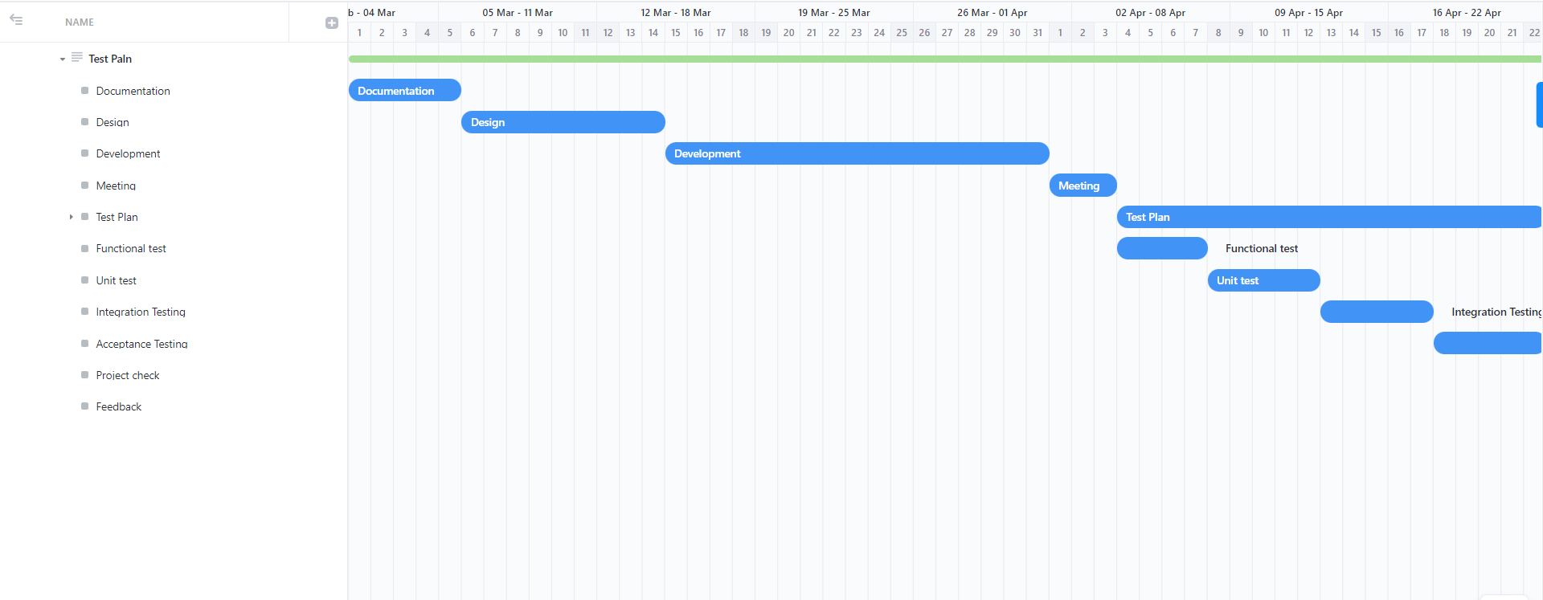

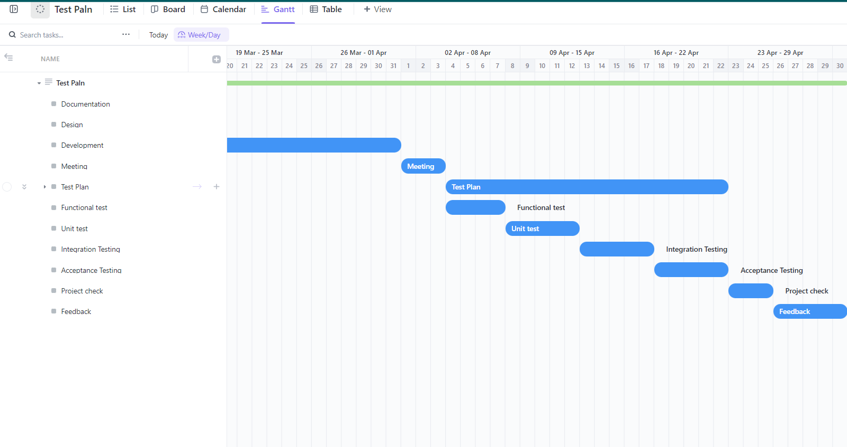

# PLANNING RISKS AND CONTINGENCIES

Every project should include planning for risks and unanticipated events, but hospital management systems are especially essential for patient care. The followings are some typical risks and potential backup plans that should be taken into account during the planning stage:

1. System failure risk: System failure risk may have an impact on patient care and safety. Duplication, backups, and failover techniques should all be included in a backup strategy in order to avoid any downtime. The backup strategy must have processes for system recovery, communication, and risk reduction.
2. Failure of a Third-Party Vendor: This risk can affect the system's reliability and working properly. The backup strategy should contain protections against vendor failure such as contract rules, performance monitoring, and due investigation. The backup strategy should contain procedures for choosing an alternate vendor, transferring to them, and risk reduction.

# APROVALS

|  |  |
| --- | --- |
| Project Sponsor- FARHAN | Approved |
| Development Management- FARHAN | Approved |
| EDI Project Manager- SADMAN | Approved |
| RS Test Manager-ARPON | Approved |
| RS Development Team Manager- ARPON | Approved |
| Reassigned Sales- FARHAN | Approved |
| Order entry EDI Team Manager- SADMAN | Approved |